**TUGAS 7 NF ACADEMY**

**FULLSTACK WEB DEVELOPER**

**‘Database MySQL/MariaDB’**

Nama : Reyvaldo Arrizky Safaatulloh

NIM : 0110222213

Prodi/Kampus : Teknik Informatika STT Terpadu Nurul Fikri

SOAL

SOAL 4.1

Tampilkan data berikut menggunakan join table:

|  |  |  |  |  |  |  |
| --- | --- | --- | --- | --- | --- | --- |
| **Pesanan** | | | **Pelanggan** | | **Kartu** | |
| id | tanggal | total | kode | nama | nama kartu | diskon |

Jawab :

SELECT

pesanan.id,

pesanan.tanggal,

pesanan.total,

pelanggan.kode AS kode_pelanggan,

pelanggan.nama AS nama_pelanggan,

kartu.nama AS nama_kartu,

kartu.diskon

FROM pesanan

INNER JOIN pelanggan ON pesanan.pelanggan_id = pelanggan.id

INNER JOIN kartu ON pelanggan.kartu_id = kartu.id;

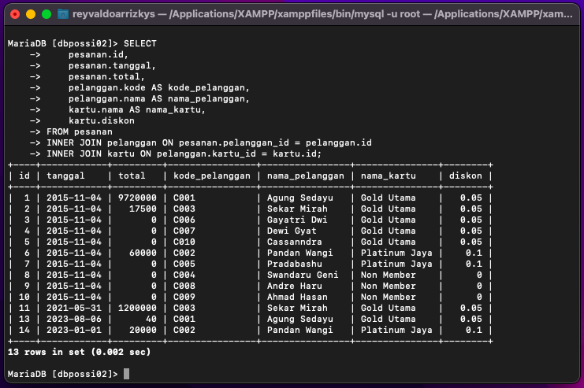

|  |  |  |  |  |  |  |  |
| --- | --- | --- | --- | --- | --- | --- | --- |
| **Pembelian** | | | | | **Produk** | **Vendor** | |
| Id | tanggal | nomor | jumlah | harga | nama | nama | kontak |

Jawab :

SELECT

pembelian.id,

pembelian.tanggal,

pembelian.nomor,

pembelian.jumlah,

pembelian.harga,

produk.nama AS nama_produk,

vendor.nama AS nama_vendor,

vendor.kontak

FROM pembelian

INNER JOIN produk ON pembelian.produk_id = produk.id

INNER JOIN vendor ON pembelian.vendor_id = vendor.id;

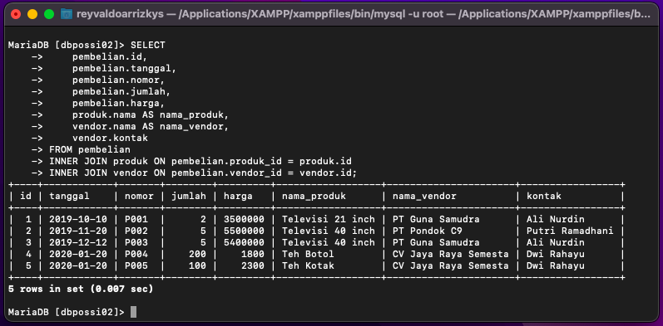

|  |  |  |  |  |  |  |  |  |
| --- | --- | --- | --- | --- | --- | --- | --- | --- |
| **Pesanan** | | | **Pelanggan** | **Produk** | | **Jenis produk** | **Pesanan items** | |
| id | tanggal | total | nama | kode | nama | nama | qty | harga_jual |

Jawab :

SELECT

pesanan.id,

pesanan.tanggal,

pesanan.total,

pelanggan.nama AS nama_pelanggan,

produk.kode AS kode_produk,

produk.nama AS nama_produk,

jenis_produk.nama AS nama_jenis_produk,

pesanan_items.qty,

produk.harga_jual

FROM pesanan

INNER JOIN pelanggan ON pesanan.pelanggan_id = pelanggan.id

INNER JOIN pesanan_items ON pesanan.id = pesanan_items.pesanan_id

INNER JOIN produk ON pesanan_items.produk_id = produk.id

INNER JOIN jenis_produk ON produk.jenis_produk_id = jenis_produk.id;

